***Requirements Table:***

|  |  |  |  |  |
| --- | --- | --- | --- | --- |
| **Game Description** | **Functional Requirements & Priorities** | | | |
| **High Priority** (i.e. must have) | **Medium Priority** (i.e. Should have) | **Low Priority** (i.e. Could have) | **No Priority** (i.e Won’t have) |
| *PnP* is a 2D platform fighter in which the player must eliminate all other player opponent's on the battlefield. To do so, the player must shoot a projectile punch and hit the opposing player(s) until the opposition’s health is zero. Players can traverse by running, jumping within a 2d environment and can soar to a target wall or ceiling on the map aiming and shooting a plunger projectile towards it. | **1.** **Player: -**Controlled by player with WASD keys. Capable of lateral/horizontal.  -Projectile aiming controlled by mouse to screen location.  -Can shoot a projectile towards users mouse location  **2. Punching Gun:**  -Fired with left click  -Lowers opposition’s health on contact.  -pushing force upon contact; hit character will be pushed 7 character spaces from contact  **3. Plunger Gun:**  -Fired with right click  - Moves player to any map boundary fired at (i.e. wall,ceiling, floor)  -pulling force of where in player gets pulled 7 character spaces  **4. Game:** -At least 2 players  -Player with remaining health and no opposition with health is the winner of the match. Upon which the match ends. | **1. Punching gun:**  - Repelling force on contact with opponent.  **2.Plunger Gun:** -Immobilization (stun) on contact.  - Pulling force; Draws hit opponent towards player.  **3.Menu:**  - Select Character  - Select Map  -Go to and fro different menus. For example, you can back out of the map selection back to character selection)  - Upon the match ending, players are sent back to lobby or a menu pops up in which the host can decide to go back to a certain selection on the map.  - | 1. **Dodge:**  -Players dash 3 character spaces with i-frames. | **1.3D environment:** Player movement that involves movement along the z axis. |

***Use-Case Diagram:***

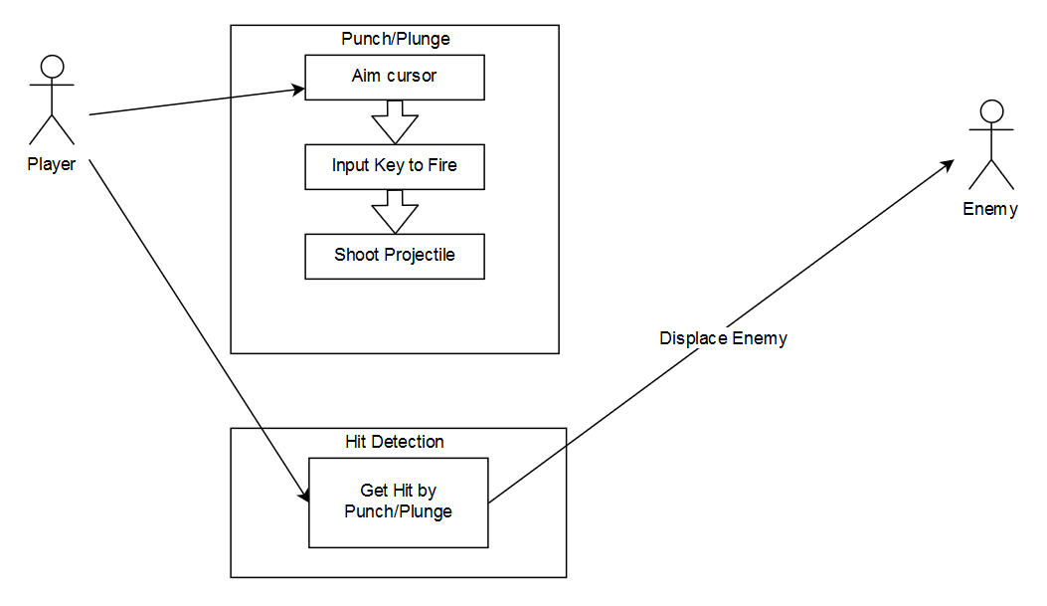

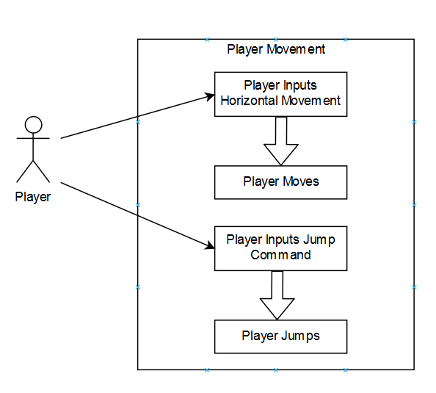

***Use-Case Scenarios:***

|  |
| --- |
| Player Movement and Jumping - Actor Player |
| 1. Player will press WASD key and move in the corresponding to the direction 2. Player will move up when inputting the spacebar key 3. Upon moving off the a ledge or wall the player will fall with gravity in motion 4. Upon falling the player may move right or left with WASD keys |
| Player Punching and Health Loss - Actor Player |
| 1. Player starts game with 3 health 2. Player will use mouse to aim on screen. 3. The aim will be of a vector as the players position as the origin and mouse position as the end point. 4. Player will input left mouse click to punch. 5. A punch glove projectile will move from the point of origin through the endpoint until the projectile has a collision. 6. Upon the punch glove projectile hitting a player, the hit player will lose 1 health point of 3 and move 7 character spaces away from the point of collision. 7. If a player has run out of health the player is eliminated from the match. |
| Player Plunging - Actor Player |
| 1. Player will use mouse to aim on screen. 2. The aim will be of a vector as the players position as the origin and mouse position as the end point. 3. Player will input right mouse click to plunge. 4. The plunger projectile will move from the point of origin through the endpoint until the projectile has a collision. 5. Upon the plunger projectile hitting a player, the hit player will move 7 character spaces towards the point of collision, and be stunned for 1 second. 6. Upon the plunger projectile hitting a wall, floor, or ceiling barrier, the shooting player will move towards the point of contact at 7 character spaced per second. |

***Requirement Fulfillment Chart:***

|  |  |  |  |  |
| --- | --- | --- | --- | --- |
| Requirement Name | Player Controller | Network  Manager | Projectile  Controller | Game State  Manager |
| Player Movement | ✓ |  |  |  |
| Punch Gun | ✓ |  |  |  |
| Plunger Gun | ✓ |  |  |  |
| Game State |  |  |  | ✓ |
| Networked Game |  | ✓ |  |  |
| Punch Gun Projectile |  |  | ✓ |  |
| Plunge Gun Projectile |  |  | ✓ |  |
| Game Menu |  |  |  | ✓ |
| Soft Requirements |  |  |  |  |
|  |  |  |  |  |

***Module Relationship Chart:***

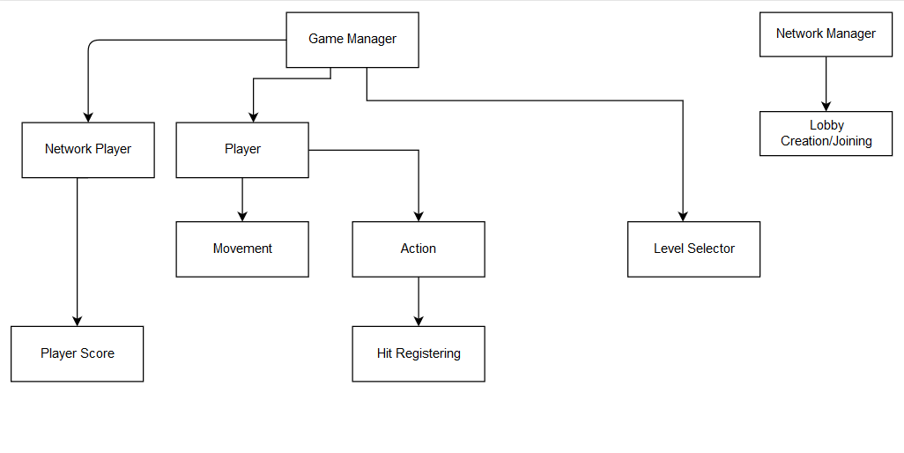

***Class Diagram:***

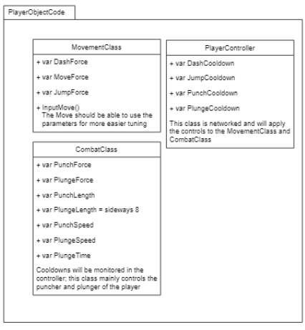

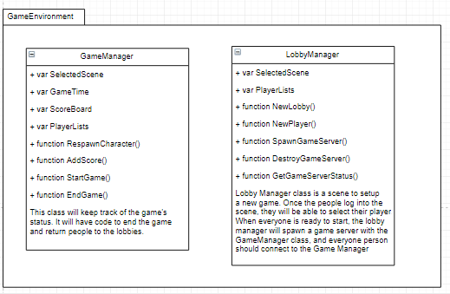

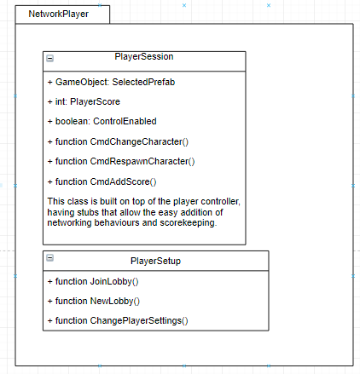

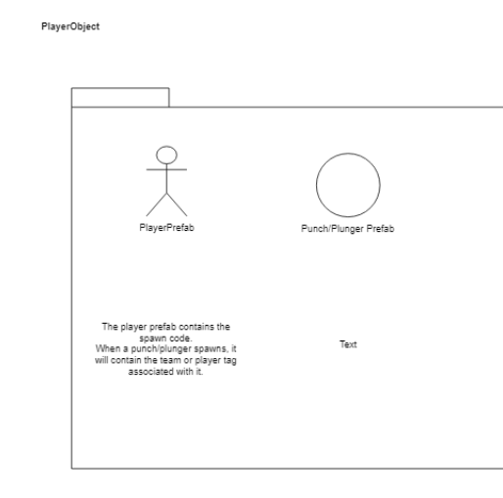

*Text ⇒ “The projectile prefab is going to travel with a pre directed vector. Upon collision with anything, it will delete itself. Upon collision with another player, it will apply side effects to knock back/pull back the player and apply optional damage.”